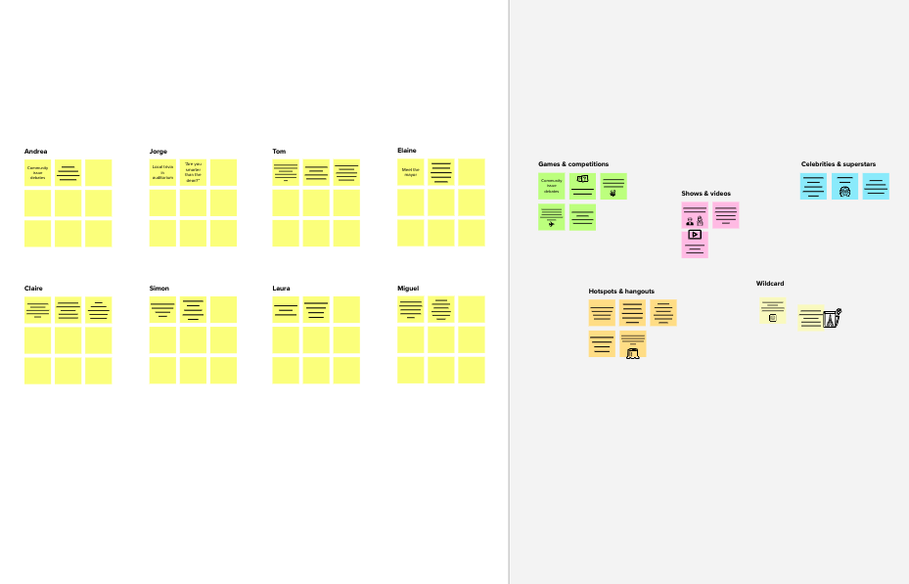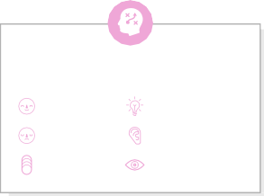

**Brainstorm**

& idea prioritization

**Team id**:PNT2022TMID41960

Date :14, september 2022

## Before you collaborate

**TIP**

You can select a sticky note and hit the pencil [switch to sketch] icon to start drawing!

A little bit of preparation goes a long way with this session. Here’s what you need to do to get going.

**10 minutes**

Application with GPS Tracking for specially abled children

**PROBLEM**

Increasing the rate of child kidnapping

**1**

## Define your problem statement

Susmi is a busy artist who needs an assistant to track her child and to ensure the child's safety and security Since she had a differently abled child.

**5 minutes**

## 2

**Brainstorm**

Write down any ideas that come to mind that address your problem statement.

**10 minutes**

**3**

## Group ideas

Take turns sharing your ideas while clustering similar or related notes as you go. In the last 10 minutes, give each cluster a sentence-like label. If a cluster is bigger than six sticky notes, try and see if you and break it up into smaller sub-groups.

**20 minutes**

**4**

## Prioritize

Your team should all be on the same page about what's important moving forward. Place your ideas on this grid to determine which ideas are important and which are feasible.

**20 minutes**

## After you collaborate

You can export the mural as an image or pdf to share with members of your company who might find it helpful.

**Quick add-ons**

Contact lens or specs fitting in children

Contact lens or specs fitting in children

Use this template in your own

category 1

brainstorming sessions so your team can unleash their imagination and

**J.NIVEDA**

**ANISHA BRIGHTLIN J**

**THANYA T**

**VIJAYA LAKSHMI Y**

**TIP**

Add customizable tags to sticky notes to make it easier to find, browse, organize, and categorize important ideas as themes within your mural.

1. **Share the mural**

**Share a view link** to the mural with stakeholders to keep them in the loop about the outcomes of the session.

1. **Export the mural**

Export a copy of the mural as a PNG or PDF to attach to

# start shaping concepts even if you're not sitting in the same room.

**10 minutes** to prepare

**1 hour** to collaborate

1. **Team gathering**

Solution for the child tracking system is discussed among the team members.

1. **Set the goal**

The will be focused on to prevent kidnapping and reducing the number of missing child

**NIVETHA M**

category 2

FILIP, A SIMPLE MOBILE DEVICE THAT CHILDREN AGED Between 5 TO 11 COULD WEAR ON THEIR SCHOOL BAGS OR POUCH

Driving apps includes geo-fencing system to monitor children

emails, include in slides, or save in your drive.

## Keep moving forward

**Strategy blueprint**

**2-8 people** recommended

Wearable tracking device

FILIP, A SIMPLE MOBILE DEVICE THAT CHILDREN AGED BETWEEN 5 TO 11 COULD WEAR ON THEIR SCHOOL BAGS OR POUCH

Chip or tracking bug

1. **Learn how to use the facilitation tools**

Use the Facilitation Superpowers to run a happy and productive session.

[**Open article**](https://support.mural.co/en/articles/2113740-facilitation-superpowers)

## Key rules of brainstorming

Application with GPS Tracking for speacially abled children

To run an smooth and productive session

Wearable tracking device

Chip or tracking bug

Define the components of a new idea or strategy.

[**Open the template**](https://app.mural.co/template/e95f612a-f72a-4772-bc48-545aaa04e0c9/984865a6-0a96-4472-a48d-47639307b3ca)

**Customer experience journey map**

Stay in topic. Defer judgment.

Encourage wild ideas. Listen to others.

## Importance

Driving apps includes geo-fencing system to monitor children

Application with GPS Tracking for specially abled children

If each of these

Understand customer needs, motivations, and obstacles for an experience.

[**Open the template**](https://app.mural.co/template/b7114010-3a67-4d63-a51d-6f2cedc9633f/c1b465ab-57af-4624-8faf-ebb312edc0eb)

Driving apps includes geo-fencing system to monitor children

FILIP, A SIMPLE MOBILE DEVICE THAT CHILDREN AGED BETWEEN 5 TO 11 COULD WEAR ON THEIR SCHOOL BAGS OR POUCH

Go for volume. If possible, be visual.

tasks could get

done without any difficulty or cost, which would have the most positive impact?

**Strengths, weaknesses, opportunities & threats**

Identify strengths, weaknesses, opportunities, and threats (SWOT) to develop a plan.

|  |  |
| --- | --- |
|  |  |
|  |  |

[**Open the template**](https://app.mural.co/template/6a062671-89ee-4b76-9409-2603d8b098be/ca270343-1d54-4952-9d8c-fbc303ffd0f2)

**TIP**

Category 3

Participants can use their cursors to point at where sticky notes should go on the grid. The facilitator can confirm the spot by using the laser pointer holding the **H key** on the keyboard.

Chip or tracking bug

Contact lens or specs fitting in children

[**Share template feedback**](https://muralco.typeform.com/to/CiqaHVat?typeform-source=app.mural.co)

Wearable tracking device

[**Share template feedback**](https://muralco.typeform.com/to/CiqaHVat?typeform-source=app.mural.co)

## Feasibility

Regardless of their importance, which tasks are more feasible than others? (Cost, time, effort, complexity, etc.)

**Template**

**Need some inspiration?**

See a finished version of this template to kickstart your work.

[**Open example**](https://app.mural.co/template/e5a93b7b-49f2-48c9-afd7-a635d860eba6/93f1b98d-b2d2-4695-8e85-7e9c0d2fd9b9)